API TESTING

Swagger Testing
Swagger UI was used to test all backend APIs. It provides an interactive interface to execute API requests and verify responses.

    - Product API Testing

- POST METHOD
Creates a new Product in the Database
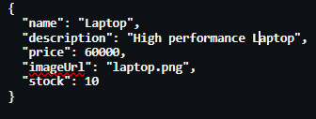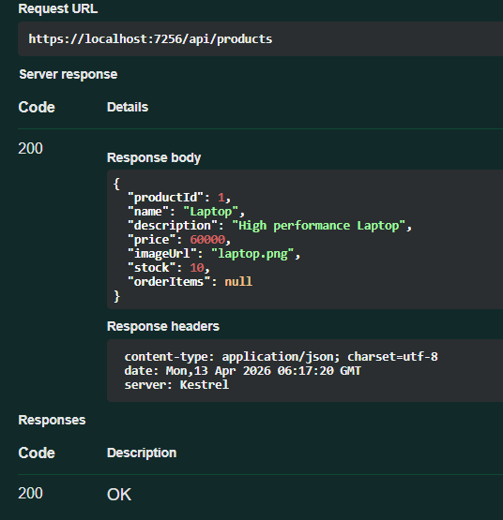

- GET METHOD
Retrieves all Products
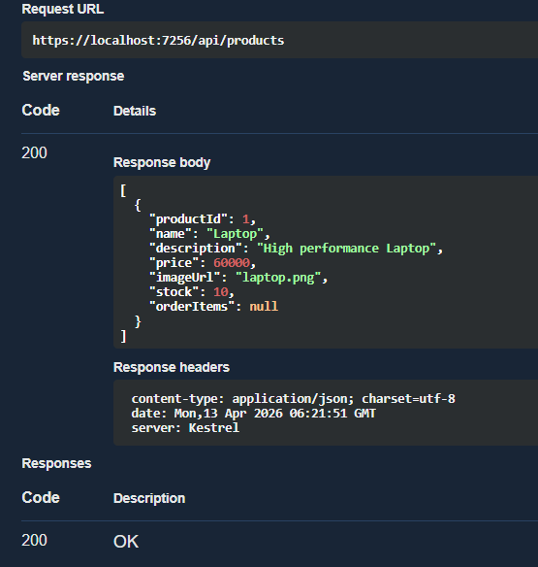

- GET BY ID
Fetches Product using Id
Success 200 (Wrong Id) Error 404
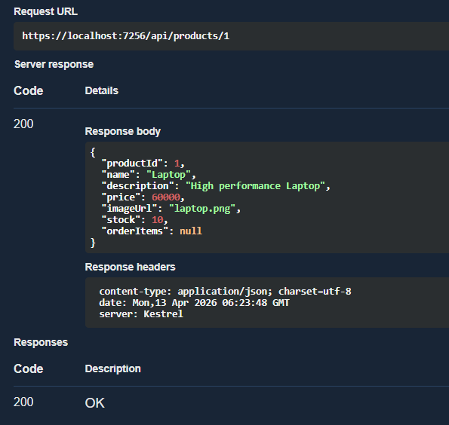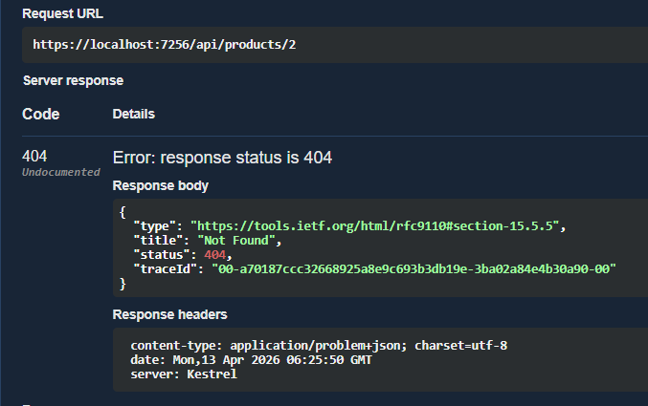

- PUT METHOD
Updates Product Details
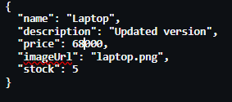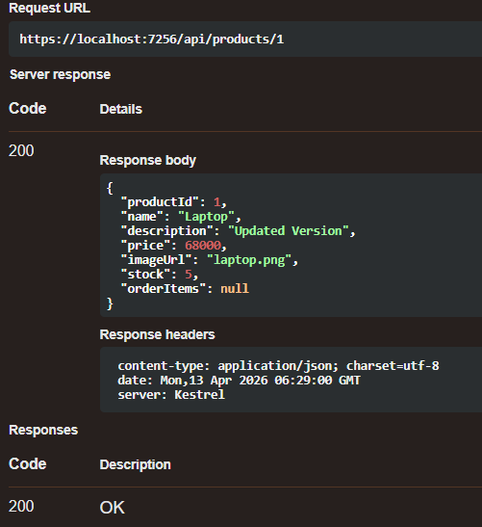

- DELETE METHOD
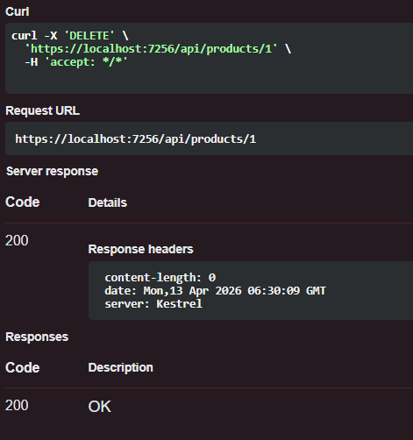

1.1.2 Order API Testing
- PSOT METHOD
Creates order from cart items and calculates total
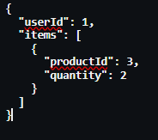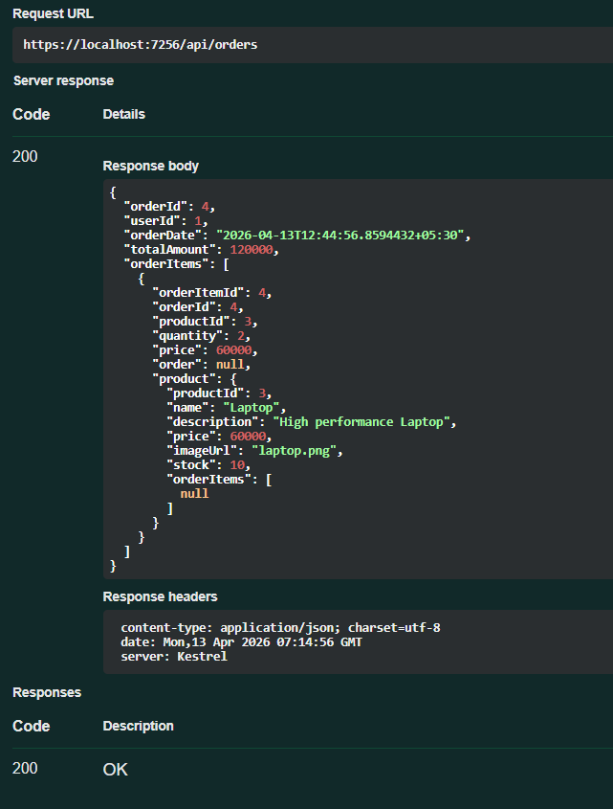

- GET METHOD
Retrieves all orders
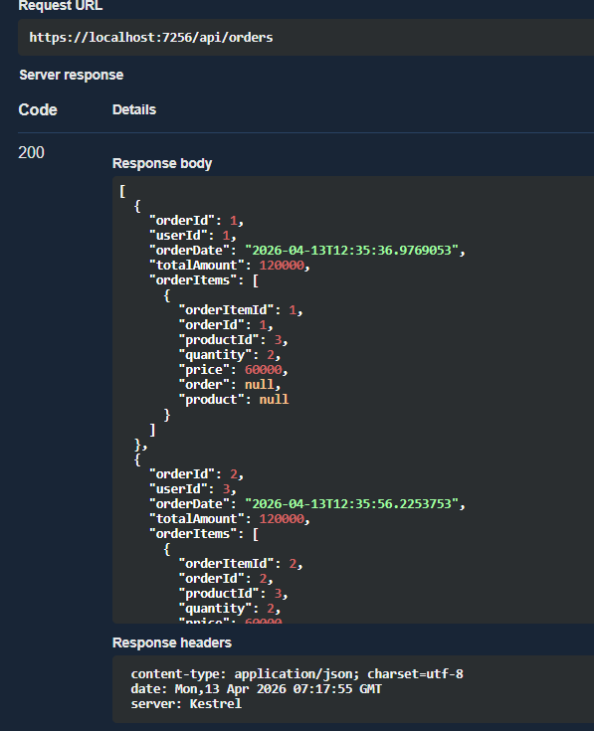
- GET ORDER BY ID
Fetches specific order by id
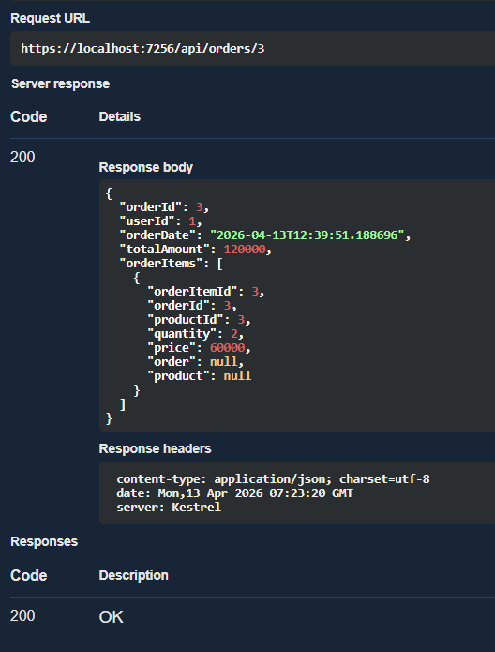

1.1.3 VALIDATION
Case 1: Product not found
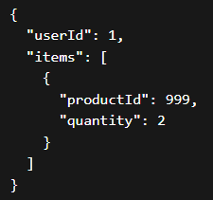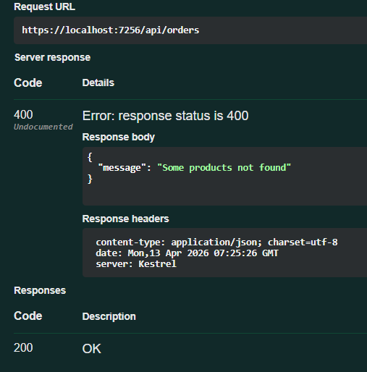

Case 2: Invalid Quantity
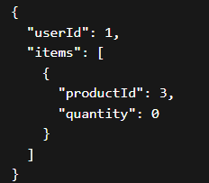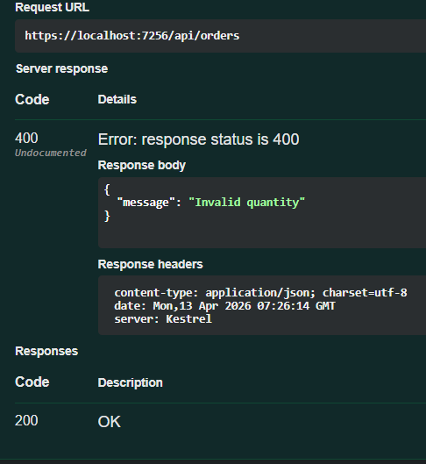

Case 3: Empty cart
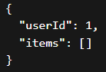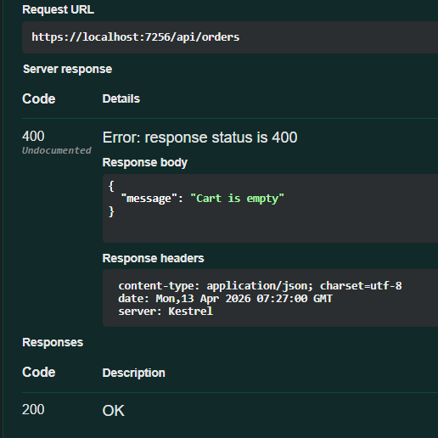

Postman Testing
Postman was used to test APIs externally by sending HTTP requests and validating responses.

    - Products API Testing
- GET METHOD
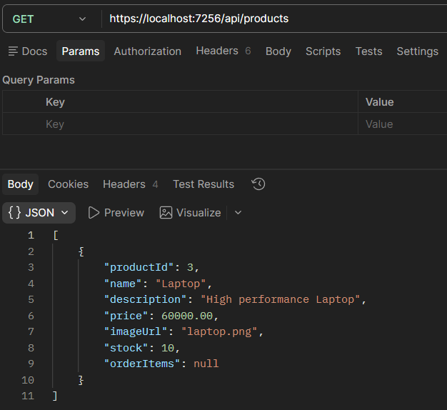

- POST METHOD
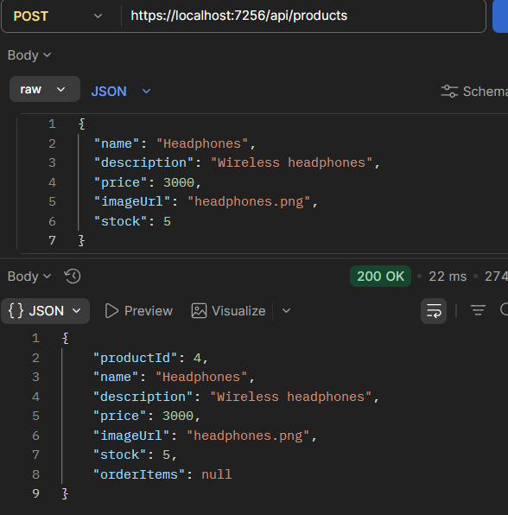

- PUT METHOD
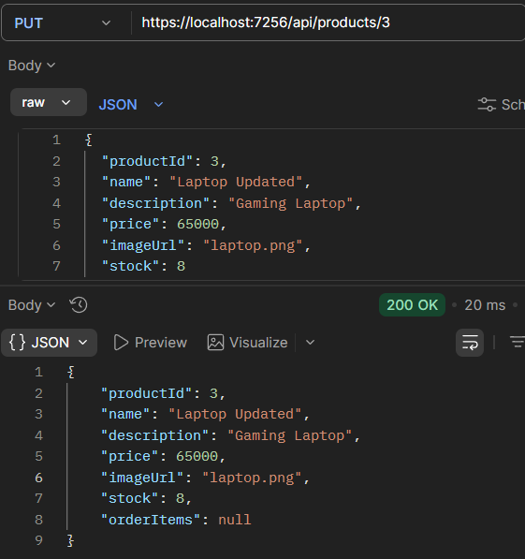
- DELETE METHOD
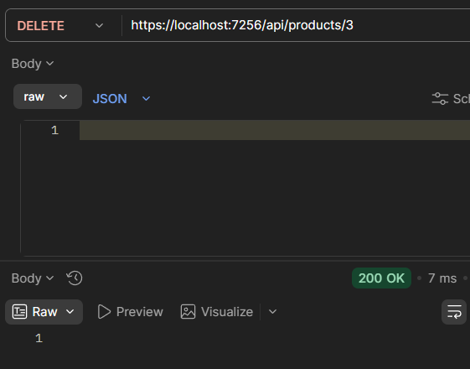

1.2.2 Order API Testing
- CREATE ORDER (POST METHOD)
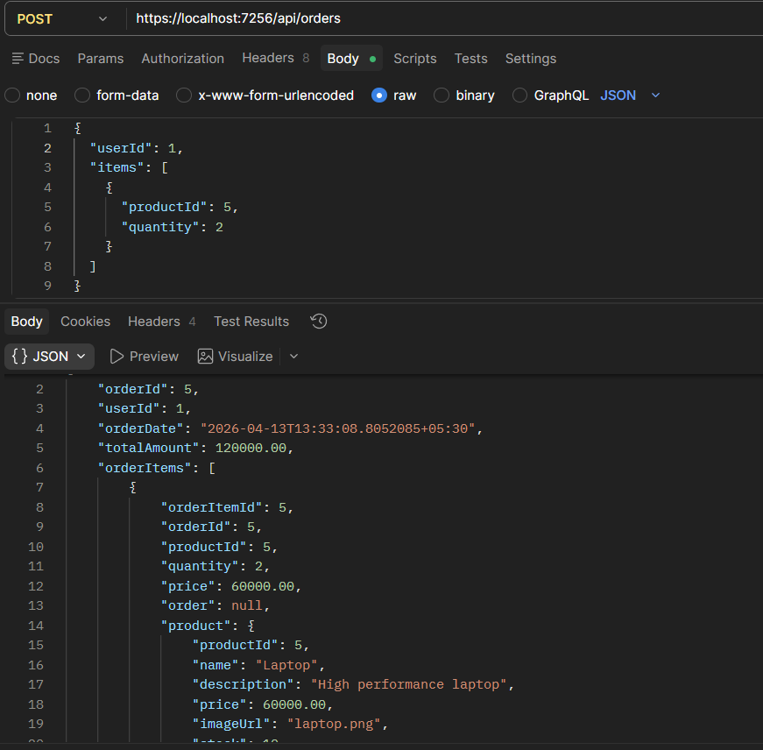

- GET METHOD
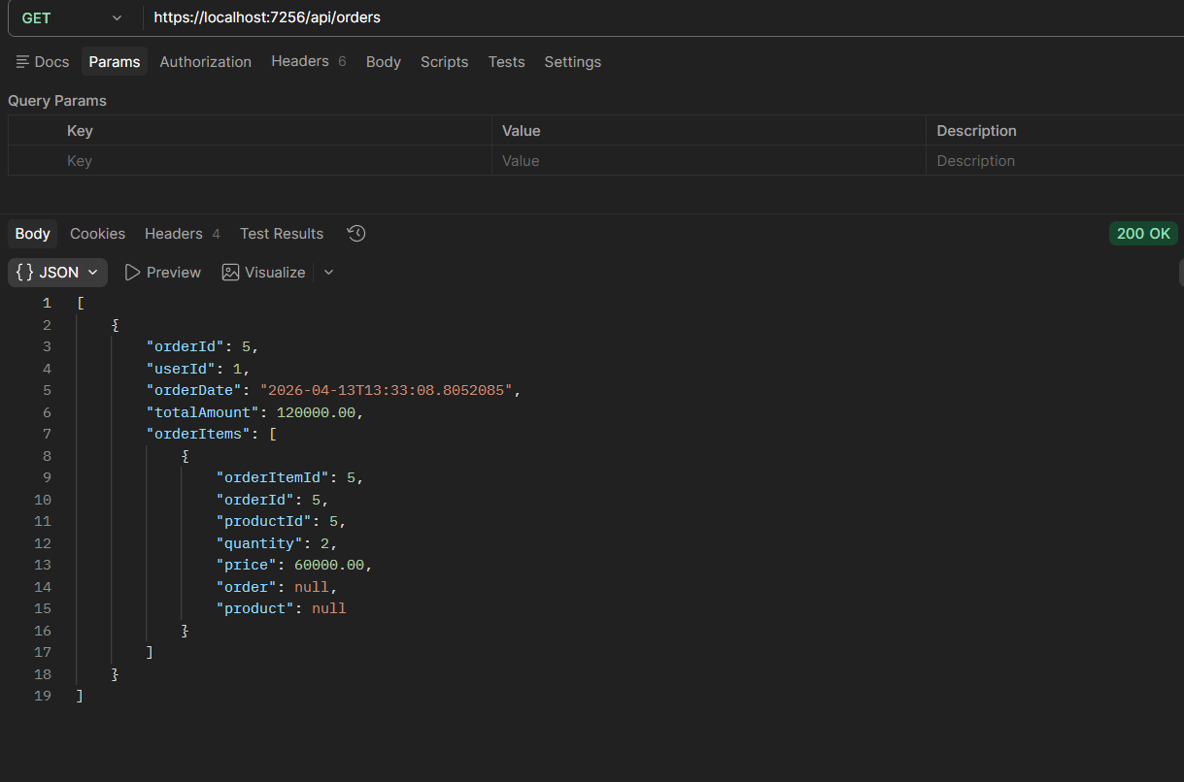

1.2.3 Validation
- Product Not Found
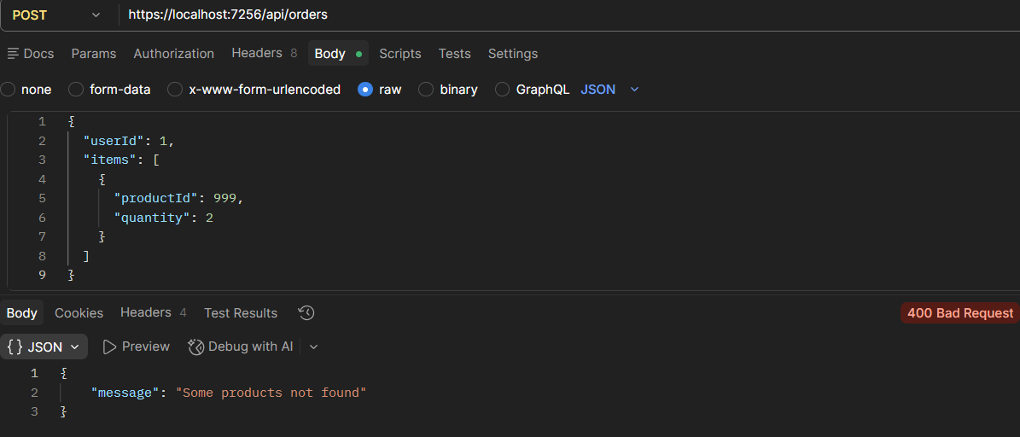

1.3 Summary

All APIs were successfully tested using Swagger and Postman. The application correctly handles CRUD operations, order processing, and validations. Proper error messages are returned for invalid inputs, ensuring robustness of the system.

